YAMAPA RIVER FALL INSECTS OF 2012

Ryan Zimmerman

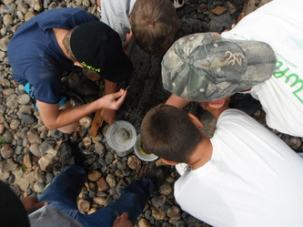

September 12, 2012
(9/12/2012)

Riverwatch of 2012
Purpose: The purpose of collecting these aquatic insects is to use them as water quality indicators.

Materials: To conduct this sample you will need a bug’s net, tweezers, a bowl, and rubbing alcohol.

Hypothesis: I hypothesize that if we collect a specific amount of sensitive aquatic insects, then the water quality of the Yampa River will be healthy.

Procedure: First you have to set up the bug net in the river and place rocks on the bottom so bugs cannot escape from underneath. Second, walk ten steps upstream and place yourself in front of the net so the kicked up debris travels towards the collection zone. Next, dig a trench with your feet, dislodging every rock between yourself and the bug net. Repeat this step three times. Then, pick up the net, place it on the beach, and pick out the insects with tweezers for 5 mins. Repeat this 3 times with your different samples. Finally, place the bugs in a bowl of rubbing alcohol to kill the bugs, and to store them for later.
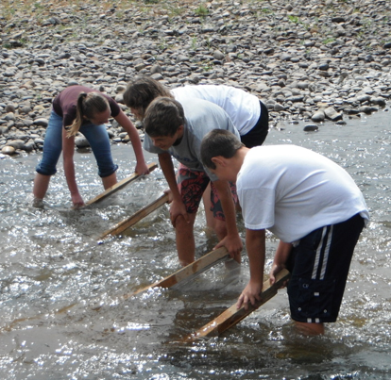

Riparian Description: South Beach is part of the Yampa River State Park system. It’s located about 3 miles southwest of Craig, Colorado. It is covered in willows, cottonwoods and small shrubs. During our samples, we disturbed a sand hill crane and a few deer. The east side of the river is channeled out for the three pumps stationed there. On the west side of the Yampa River, are Gambian bags. They were placed there so the river runs toward the pumps. The average depth of the river was twelve to fourteen inches deep. The average width was about ten to twelve yards. The river was much lower this year than last. The gravel bar shown in the picture was much bigger when we sampled. The bottom of the river was somewhat mossy and completely covered with aquatic insects.

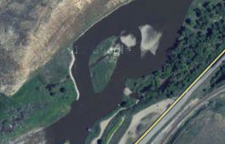
This is a picture of South Beach.

Data:

BUG | # | TOLERENCE | INDEX
Rat tailed maggot larva | 41 | T | 3
Cranefly larva | 431 | F | 5
Midge Pupa | 38 | T | 3
Dragonfly nymph | 76 | F | 5
Blackfly larva | 24 | T | 3
Fingernail clam | 11 | F | 5
Crayfish | 7 | F | 5
Caddisfly larva | 9 | S | 3
Mayfly nymph | 40 | S | 3
Damselfly nymph | 13 | F | 5
Stonefly nymph | 87 | S | 3

Analysis: After collecting these aquatic insects, we sorted and classified them. We first placed the insects from our sample bowl onto white paper and sorted them. After sorting every insect, we classified the insects using the index (shown later). We recorded this data into a table. Using the index, we were able to determine the water quality of the Yampa River. Depending on the amount, and type of insects we found, would determine the water quality. If we had more than 22 insects, or 4 sensitive insects, the water quality is excellent. If we had 17-22 insects, or 2 sensitive insects, the water quality is good. Fair water quality is 11-16 insects or 1 sensitive insect, and poor water quality is less than 11 insects and no sensitive insects. We were one insect away from our water quality being excellent. Our water quality was good.

Conclusion: My hypothesis was correct based on the bug data we collected at South Beach. I conclude that the water quality of the Yampa River is quite healthy. A majority of the aquatic insects we collected are highly sensitive to poor water quality and pollution. Therefore, the water quality must be good otherwise we wouldn’t of collected these aquatic insects from South Beach. Based on the aquatic insect species index, there is a high number of sensitive insects present at South Beach. Having the high number of sensitive aquatic insects present indicates that the results are reliable.
Appendix:

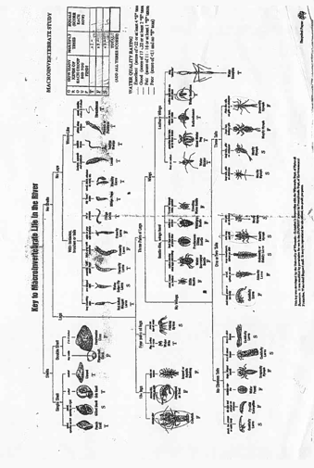
Index
Aquatic insects:

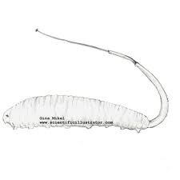
scientificillustrator.com
This is a rat tailed maggot larva. It can live almost anywhere including oxygen-deprived water.

people.virginia.edu

The crane fly larva is one species we found during our collections. It indicates that the water is clean.
islandwood.org
This is a midge pupa.
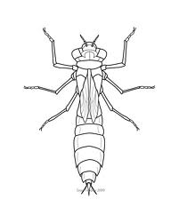
seantwiddy.com
Here is a dragonfly nymph. They are found mainly around ponds, streams, lakes, and marshes.

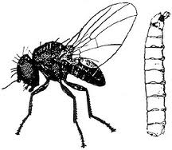

crawford.tardigrade.net
The blackfly lives by feeding on the blood of mammals.
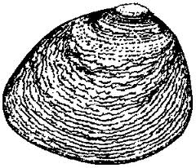
seagrant.gso.uri.edu
The fingernail clam lives on the bottom of streams or ponds. It never gets bigger than a fingernail.

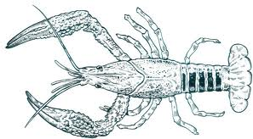
sirenseasa.com
The crayfish (aka crawdad, or crawfish) are like freshwater lobsters. They live in streams and brooks that don’t freeze to the bottom and cannot tolerate polluted water.

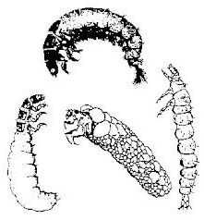
life.bio.sunysb.edu
Here are different representatives of the caddisfly larvae. They can be found in rivers, ponds, and lakes.
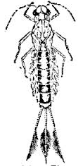
learner.org
The mayfly nymph lives in lakes and streams under rocks or decaying vegetation.
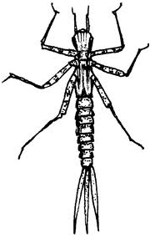
clean-water.uwex.edu
The damselfly nymph is similar to the dragonfly. Females lay eggs in water and underwater beneath rocks.

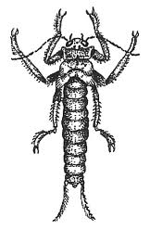
bcadventure.com
This is a stonefly nymph. It is one of the many bugs we collected during our sample.

