Aquatic Macro Invertebrates Collection

Mattie Jo Duzik

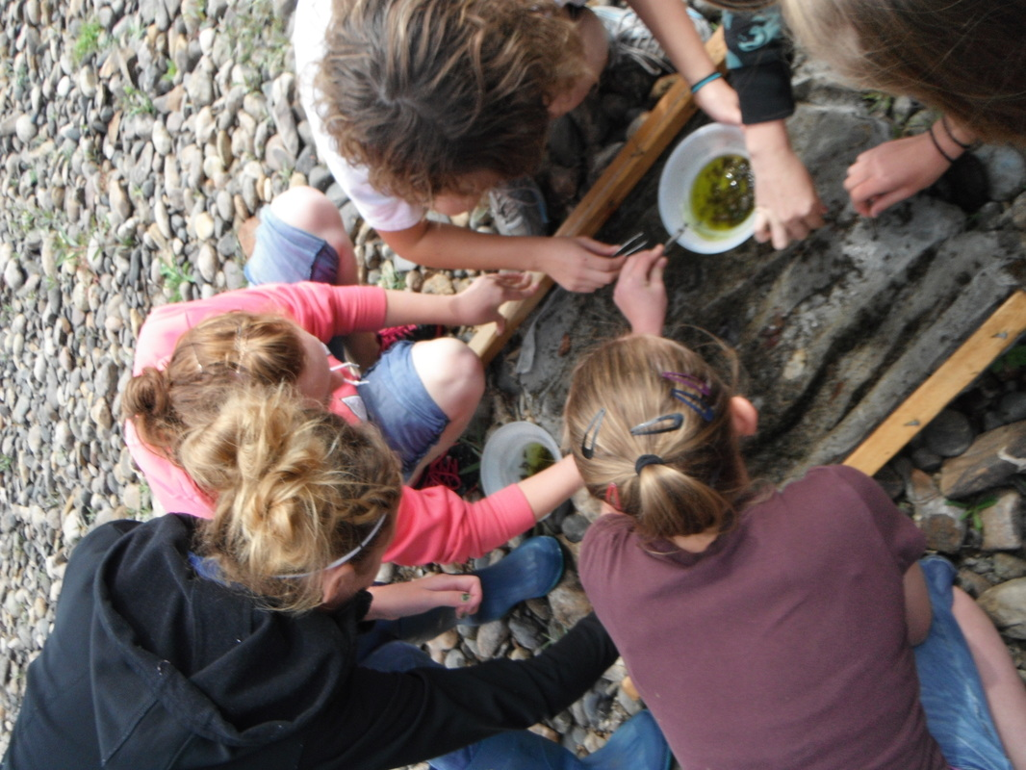

September 12th, 2012
Riverwatch 2012

Purpose: To use Aquatic Macro-Invertebrates as water quality indicators.

Materials: Aquatic Insects collecting net, closed-toe shoes (for kicking up the rocks), tweezers to sort the insects, rubbing alcohol, and a strainer.

Hypothesis: I think that our river quality is very good because it is clean, clear, and full of life. Also, I think that we will find a lot of bugs in our nets because the environment is healthy. Not to mention, when you look into the river it is clear, and has no film-like cover on the water to show that there was oil-like substances within it.

Procedure: Start in a area with some current, then place screen an angle, put rocks on the bottom of screen so there is no water flow underneath. After that, walk about ten feet upstream and displace all rocks before the screen. Then, after an adequate amount of displacing rocks, lift screen and take to shore to separate insects from algae and other non-living things. Put the macro-invertebrates in rubbing alcohol to instantly kill them. Then strain the bugs from the alcohol. Count and sort them into species.
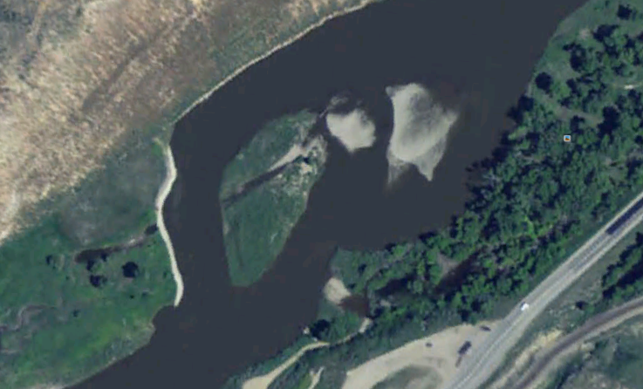

This is a Google Earth Picture of South Beach

Riparian Description: At South Beach, parts of river had been dug up and were channelized to make for more direct water flow to the Trapper Mine water pump, which was about 75-80 meters South West of where we did our bug kick. Then, there was an irrigation pump about 100 meters south West from our collection. The power plant had their own water pump, about 125 meters South West from where we did a bug kick. Shrubs, willows, Tamarisk trees, sage brush further up on hillside, little island in the middle of river with Tamarisks trees and various grasses. The river was about 10 meters to 15 meters across in different areas. It was about 2 feet deep where we tested. Other areas were about 8 feet deep. On the Northwest side there were Gambian Bags used for erosion control. Right by the Gambian Bags the water depth was about 8 or 9 feet. There were a lot of willows surrounding the area, and there was a large amount of Tamarisk trees around. Not to mention, it was very lush and green, considering we are going through a drought. Normally, the water depth where we tested would be about 3 or 4 feet deep. That is double than this year.

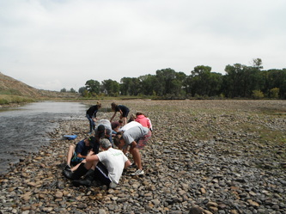

Our Aquatic Macro-Invertebrates Data

Insect Specie | Amount | Tolerance | Index
Rat-Tailed Maggot | 41 | T | 4
Crane-Fly Larva | 431 | F | 10
Midge Pupa | 38 | T | 4
Dragonfly Nymph | 76 | F | 10
Black Fly Larva | 24 | T | 4
Fingernail Clam | 11 | F | 10
Crayfish | 7 | F | 10
Caddisfly Larva | 9 | S | 4
Damselfly Nymph | 40 | S | 4
Stonefly Nymph | 13 | F | 10
Mayfly Nymph | 87 | S | 4
Dobsonfly nymph | 1 | S | 4

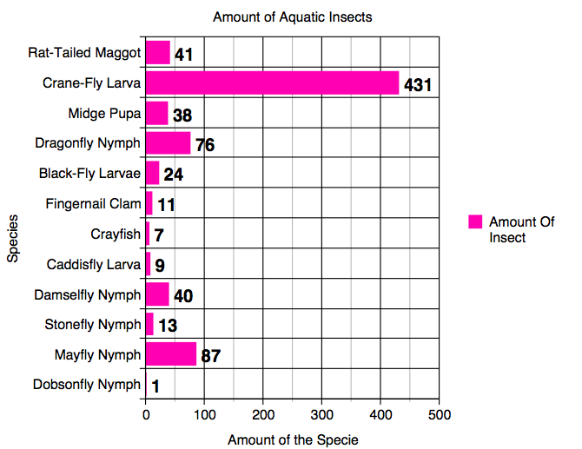

Source- http://nces.ed.gov/nceskids/createagraph/default.aspx?ID=c0bfac395955478f8201cf9418cbae7f

Some Aquatic Macro-Invertebrates and Some Facts about them

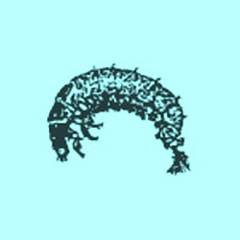 http://www4.bluevalleyk12.org/BVNW/jmohn/fieldbiology/macroinvertebrates/crayfish.htm

Caddis Fly Larvae
• Up to 1 inch long before becoming an adult fly
• Can make their cases out of many different things like sand, pebbles, and pieces of plants.
• Over 800 different species of Caddis-Fly
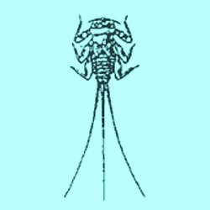http://www4.bluevalleyk12.org/BVNW/jmohn/fieldbiology/macroinvertebrates/crayfish.htm
Mayfly Nymph
• About 700 species live in North America, 2,100 in the world.
• Herbivores, they eat what they can and aren’t picky.
• Can grow to be over 1 inch long.
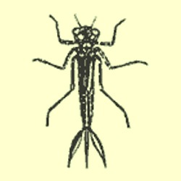
http://www4.bluevalleyk12.org/BVNW/jmohn/fieldbiology/macroinvertebrates/damselfly.htm

Damselfly Nymph
• They can live to be 2-4 years old.
• They can regrow lost appendages.
• They feed on other macro-invertebrates

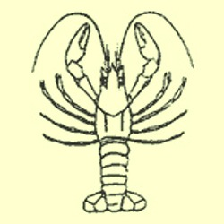
http://www4.bluevalleyk12.org/BVNW/jmohn/fieldbiology/macroinvertebrates/crayfish.htm

Crayfish
• They can get to be 6 inches long
• Hard exoskeleton
• 2 or 4 antennas
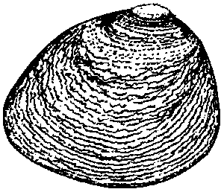

Fingernail Clam
• They can live 1-3 years.
• There are 38 different Fingernail Clam species
Fingernail Clams are self-reproducing, having the young develop in the water tubes of the adult.

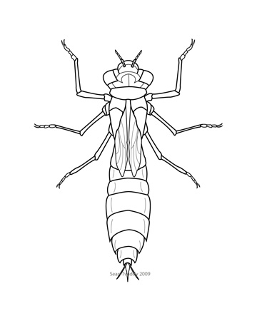
Dragonfly Nymph
Dragonfly nymphs develop in 1-4 years
They don’t have gills
They have 6 long segmented legs

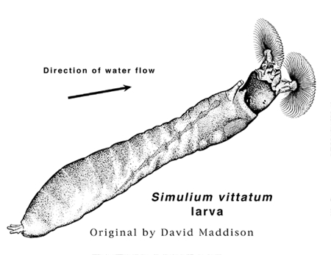
Black Fly Larvae
- They are filter Feeders
- Larvae pass through 6 stages before they become an adult
- They attach themselves to rocks and aquatic vegetation.
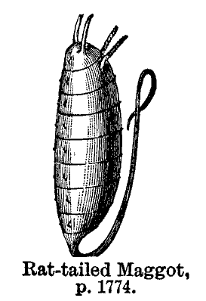
Rat-tailed Maggot
- They get to be up to 20mm long
- Tail is 30-40 mm long. It is used for a breathing tube
- This hard-bodied life stage is resistant to crushing

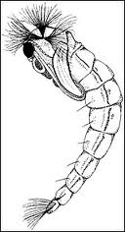
Midge Pupa
- Sometimes called “blood worms”
- They are closely related to mosquitoes
- Pupa stage doesn’t feed
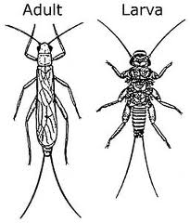
Stonefly Nymph
- Weak Fliers as adults
- Crawl Under rocks and live there
- Don’t live very long
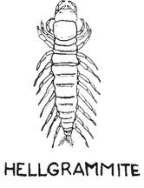
Dobson Fly Nymph
- Over 220 species of Nymphs
- Found all over
- Closely related to fishflies

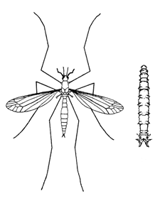
Crane fly Larvae
- Fairly easy to identify
- Lack head and tail
- Larvae is 1 inch long

Why are Aquatic macro invertebrates are good indicators of stream quality?

- All of them can be affected by the chemical, and physical conditions of the water.
- They are relatively easy to sample and identify.
- They show the effects of pollution
- Some are very intolerant of pollution.
- They are very important to the aquatic food chain.
Where really is South Beach and what we do with it recreationally?
South Beach is located about 3 miles south of Craig, off of Highway 13. South Beach isn’t just only a great place for aquatic-life, it is also a great place for recreational activities like swimming, tubing, taking the dogs for a walk, and fishing.

Where really is South Beach and what we do with it recreationally?
South Beach is located about 3 miles south of Craig, off of Highway 13. South Beach isn’t just only a great place for aquatic-life, it is also a great place for recreational activities like swimming, tubing, taking the dogs for a walk, and fishing.

Conclusion
The water quality at South Beach is excellent because of the high amount of aquatic insects with an index of S or T. Our water quality rating at South Beach was 22. We had 4 insects with a sensitive tolerance; the Caddisfly Larvae, Mayfly Nymph, Dobson fly nymph, and Stonefly Nymph. My hypothesis was correct, because the water quality was good. What I noticed is that the water is very clear, where we did our bug kick.
Where really is South Beach and what we do with it recreationally?
South Beach is located about 3 miles south of Craig, off of Highway 13. South Beach isn’t just only a great place for aquatic-life, it is also a great place for recreational activities like swimming, tubing, taking the dogs for a walk, and fishing.

Appendix

