Yampa River bug catch

By: Mikey Bingham

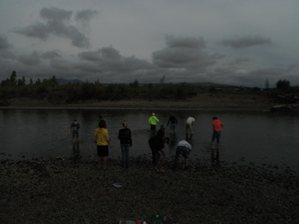

(9/11/12)

2012 River watch

Purpose: We to collect bugs to determine the water quality of the Yampa River.

Materials: Tweezers, rubbing alcohol, bugs net, bowls.

Hypothesis: I think that by the records of the bugs that we caught our water quality is good.

Procedure: First we layed down the bugs net, then we took ten steps up stream kicked up a path of rocks, and then we picked the bugs off the net and put then in the rubbing alcohol and then repeated that three times.

Riparian Description: South beach is part of the Yampa River State Park system. The river is in a channelized section, and has lots of willows and cottonwoods. The beach has lots of rocks. At the river there were some wildlife like deer, magpies, fish, and other species of birds. There is a water pump for Trapper mine, irrigation, and one for the Power Plant. The width of the river is about ten yards. In part of the channel there is a big wall of Gambian bags. Gambian bags are made out of concrete. The Gambian bags help keep the river from over flowing. The river is about fourteen inches deep. The bed of the river is very rocky, and in some places sandy. The channel at south beach is man made and they designed, so that the piles of rocks would level out by the river, but the river did not get enough water so it was very shallow. It was also made so that the perfect amount of water would get to the pumps for Trapper, Irrigation, and the power plant.

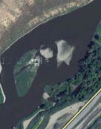
This is a picture of the channel at south beach.

Bug | #’S | Tolerance | Index
Rat tailed maggot larva | 41 | T | 3
Crane fly larva | 431 | F | 5
Midge pupa | 38 | T | 3
Dragonfly nymph | 76 | F | 5
Blackfly larva | 24 | T | 3
Fingernail clam | 11 | F | 5
Crayfish | 7 | F | 5
Caddishly larva | 9 | S | 3
Mayfly nymph | 40 | S | 3
Damselfly Nymph | 13 | F | 5
Stonefly nymph | 87 | S | 3

Based on all the data from the bugs that we caught out of our Yampa River. The water quality in the river is very healthy.

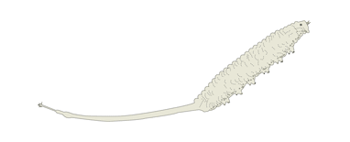
This is a rat tailed maggot larva….

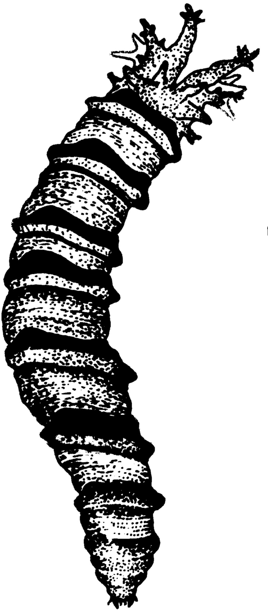Clean-water.uwex.edu
This is a Crane fly larva.

This is a Midge Pupa
islandwood.org

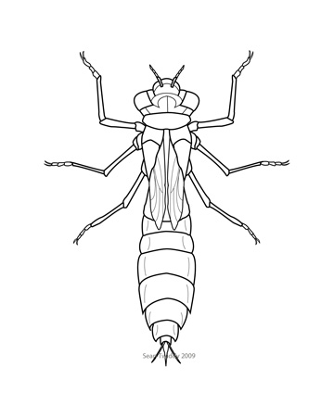seantwiddy.com
This is a Dragonfly nymph
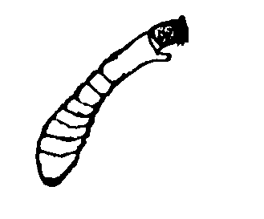This is a blackfly larva. state.ky.us

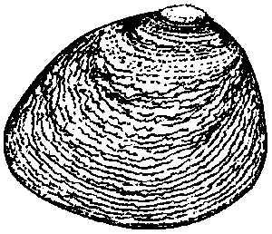Fingernail clam. pearl-guide.com

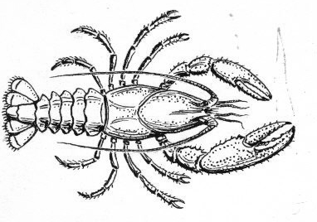This is a Crayfish. commons.wikimedia.org

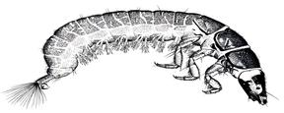This is a caddishly larva. taphonomy.wikispaces.com

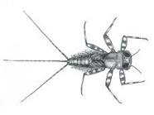This is a Mayfly nymph…flyfishusa.com

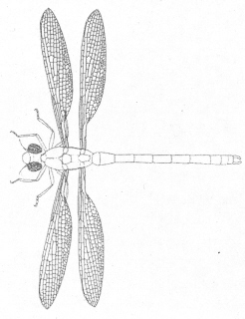This is a Damselfly nymph……. newgeology.us

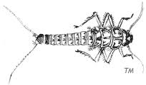This is a stonefly nymph…riverwatch.ab.ca

