Yampa River Bug Collection

Keenan Hildebrandt

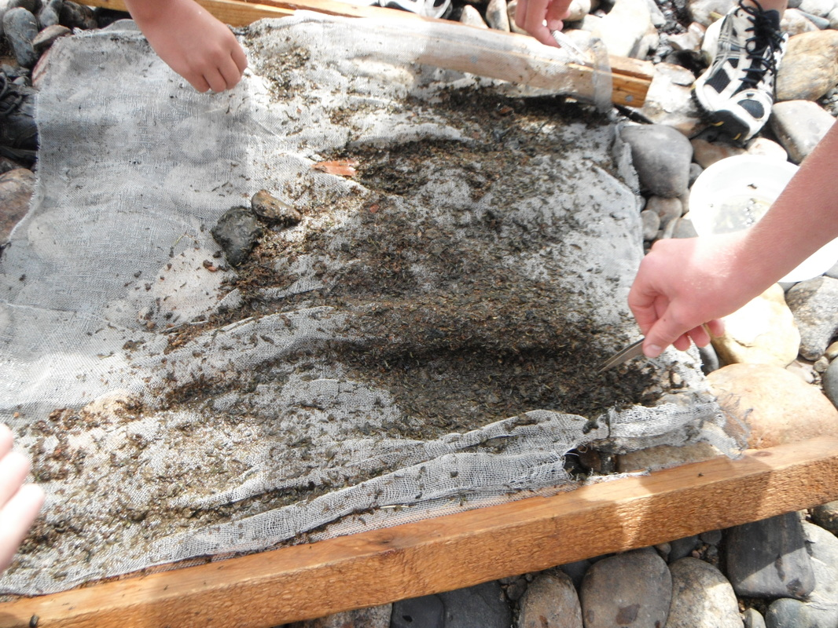

9/12/12

River Watch

Purpose: To test water quality by using bugs.

Materials: Tweezers, rubbing alcohol, window screen, and bowls.

Hypothesis: Based on the bug collection that we did I think that the river is healthy.

Procedure:
1) Place window screens on the bottom of the river while placing rocks on the bottom of the screen so that not a lot of bugs get through.
2) Move ten feet up river and kick rocks so that there is a three-inch trench and all the debris goes through the window screen. Make a trench until you come to the screen.
3) Remove screen from river and place on beach.
4) Fill bowls with alcohol.
5) Pick bugs off of screen and place in bowls. Do this for five minutes.
6) Repeat two more times.

Riparian description: South Beach is a part of the Yampa River. When we arrived at South Beach, I noticed some of Colorado’s wildlife. Magpies ate off a few carcasses beside the road. The mule deer carcasses had been killed on the highway. These dead animals may affect the cleanliness of the water because of the bacteria growing on the carcasses. If the carcasses come in contact with the water, the water could be contaminated. As we moved toward the river, we noticed raccoon footprints in the mud right next to the river. The river itself had an average width of ten feet. Its average depth was twelve to twenty four inches. Gambian bags lined the riverbank on the West side, preventing future erosion of the soil. Vegetation thrived along the river because of the rich soil and moisture. Willow trees, cottonwoods, sagebrush and various plants were observed lining the banks of the river. The asphalt highway that runs above South Beach may create man made problems for the river. Magnesium Chloride is applied on the highway to prevent ice build up in the winter season. The Magnesium Chloride could be washed into the river by rain or melting snow affecting the quality of the river.

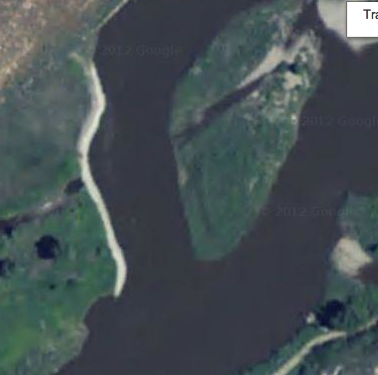

Bug | # | Tolerance | Index
Rat Tailed  Maggot larva | 41 | T | 3
Crane fly larva | 431 | F | 5
Midge Pupa | 38 | T | 3
Dragon fly Nymph | 76 | F | 5
Black Fly Larva | 24 | T | 3
Fingernail Clam | 11 | F | 5
Crayfish | 7 | F | 5
Caddis Fly Larva | 9 | S | 3
May Fly Nymph | 40 | S | 3
Damsel Fly Nymph | 13 | F | 5
Stonefly Nymph | 87 | S | 3

Conclusion: Since most of the bugs on this chart are sensitive to polluted water I am led to believe that the river is healthy.
Appendix
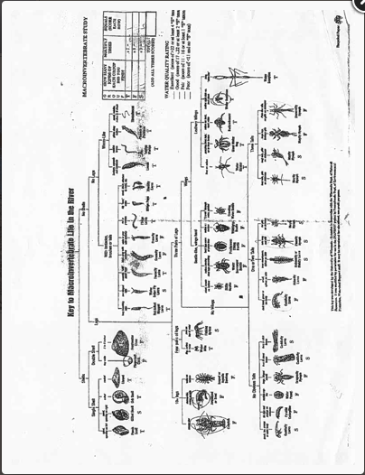

The following pictures are from google images

Rat tailed maggot larva

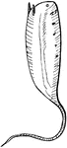

Crane fly larva

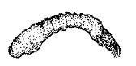

Midge pupa
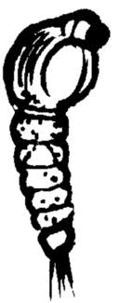

Dragonfly nymph
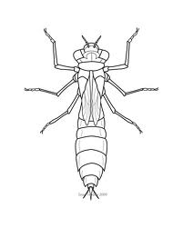
Black fly larva
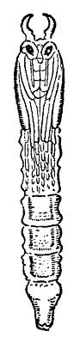

Fingernail clam
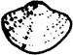

Crayfish
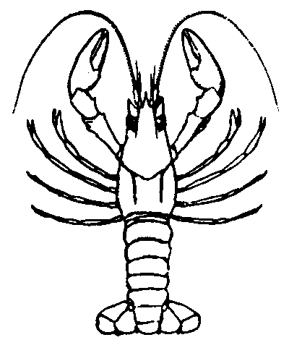

Caddis fly larva
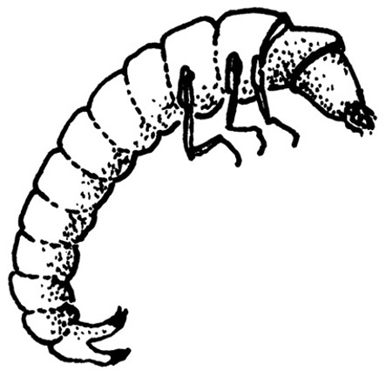

Mayfly nymph
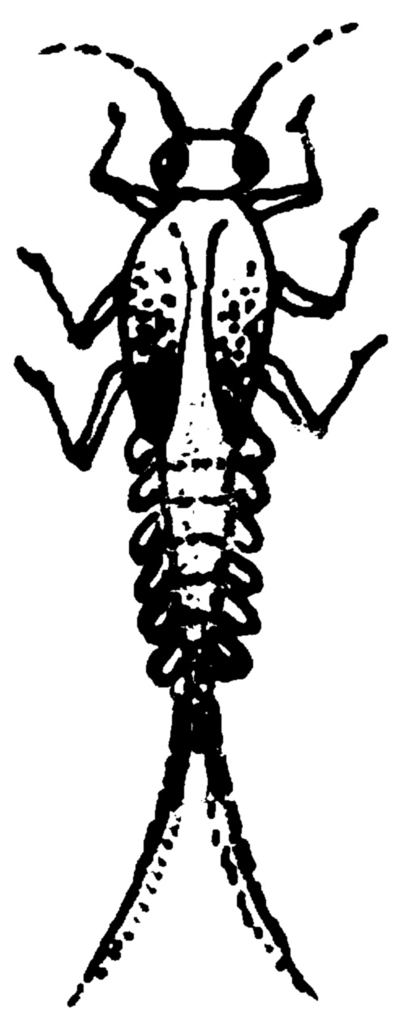

Damsel fly nymph
