Bug Collection

Connor Scranton

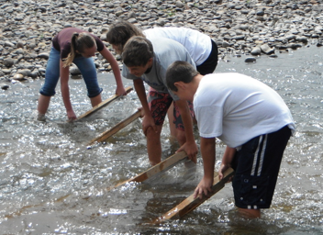

9-12-12

CMS River watch

Purpose: To find the water quality of the Yampa River using aquatic insects as water quality indicators.

Materials: We used a bug screen, tweezers, bowl and rubbing alcohol.

Hypothesis: The water quality will be acceptable based on the bugs that we will find.

Procedure: 1) We took the bug screen out in the water and set them down. 2) Three people went upstream 10 feet and kicked all the rocks in front of the screen so all the bugs on the bottom of the rocks were trapped by the screen.3) We pulled all of the bugs off that we could using the tweezers in five minutes and put them in a bowl of rubbing alcohol 4) We did this three times.

Riparian Description: South Beach is part of the Yampa River State Park. The shore is full of gravel and larger rocks on the edge of the water.
There is also a lot of sand around the banks as well. It was also very muddy in some places also. It was very lush further up the banks. It has large amounts of willows and Cottonwood trees. There are some animals including cranes and other birds. The width of the river is about 10 yards across and about knee high where we took our samples. The Gambian bags are on the left side of the river. It is to keep it channelized.
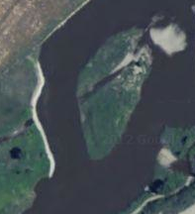

Bug | # | Tolerance | Index
Rat-tail Maggot larva | 41 | T | 3
Crane Fly larva | 431 | F | 5
Midge Pupa | 38 | T | 3
Dragon Fly nymph | 76 | F | 5
Black Fly larva | 24 | T | 3
Fingernail Clam | 11 | F | 5
Crayfish | 7 | F | 5
Caddis Fly larva | 9 | S | 3
Mayfly nymph | 40 | S | 3
Damsel Fly Nymph | 13 | F | 5
Stonefly nymph | 87 | S | 3

Water Quality: Based on all of the bugs that we have caught, and the help of the tolerance key, the water quality is good because of the amount of bugs and there tolerance levels.

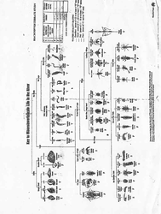

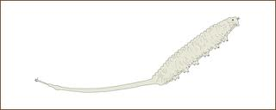
Rat- tail Maggot larva
It can get up to 20 mm long.

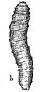
The Crane Fly larva
It usually gets between 2.5 to 5 cm.

The Midge Pupa
It can range from 1to 20mm.

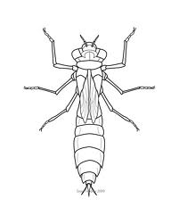
The Dragonfly Nymph
It can range from ½ to 1 ½.

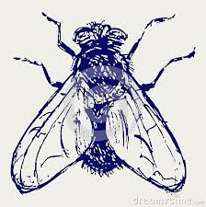

The Black Fly larva
It usually gets 5 to 15mm big.

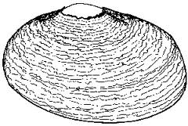
The Fingernail Clam
It ranges from 1 to 5mm big.

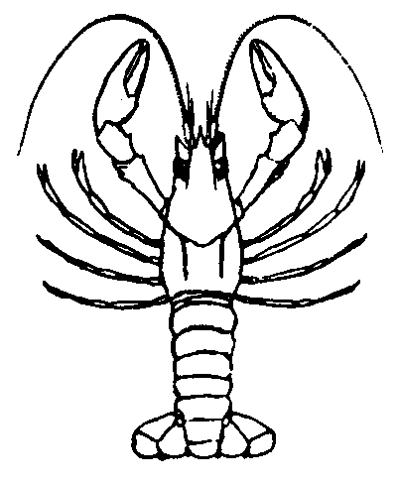
Crayfish
Usually are 2 to 6 inches tall.

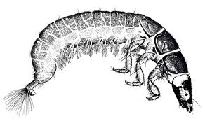
Caddis Fly larva
It is about 2.2 cm long.

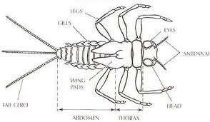

Mayfly Nymph
It usually is 5 to 12 mm.

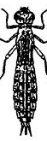
Damselfly Nymph
It is usually 25mm long.

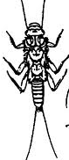
Stonefly nymph
It is 15 mm long.

