Aquatic Macroinvertibrate Collection
By Josey King
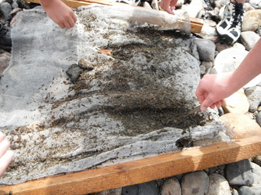

September 25, 2012

Riverwatch 2012

Purpose- The purpose was to collect aquatic insects for water quality indicators.
Materials- The materials we used were insect collecting nets, strainers, rubbing alcohol, tweezers, and closed-toed shoes.
Hypothesis- The water quality will be good in this area because, of the abundance of life and the many insects.
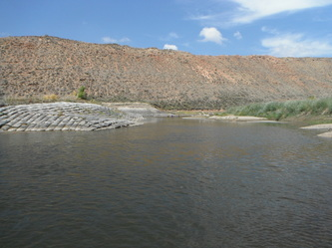

Procedure- We found an area with a small current. Then we put the net in the first location, and built up rocks around the bottom so the insects wouldn’t escape. We stepped back 10 feet and began to dislodge the rocks in front of the net. Once we got to the net we picked it up and took it to the bank. We then picked out all the insects and soaked them in rubbing alcohol. We repeated these steps 3 times.
At the school we dumped out all the bugs we collected and sorted them with tweezers. Then we counted them. We then collected our data and made our data table.

Riparian Description- South Beach is a part of the Yampa River State Park. It is located three miles south of Craig, Colorado. When we tested, it was September 12, 2012. The day before the collection we had heavy rain. On the day of, we had thick fog all morning. The area was full of willows and gravel beaches. Some tamarisk trees were scattered along the bank, and there were various types of shrubs and sagebrush. The river was approximately 10 to 15 meters wide in different spots. Where we collected bugs, the water was about 2 feet deep. In other spots it was 7-10 feet deep. Gambian bags were placed on the north side of the river, so it would protect the river’s bank from spring runoff. The water was constantly being exported to Trapper mine, Tri State G&T, and it was being used for irrigation. There is a population of Pike, Smallmouth Bass, the Colorado Pike Minnow, and Channel Catfish at South Beach.
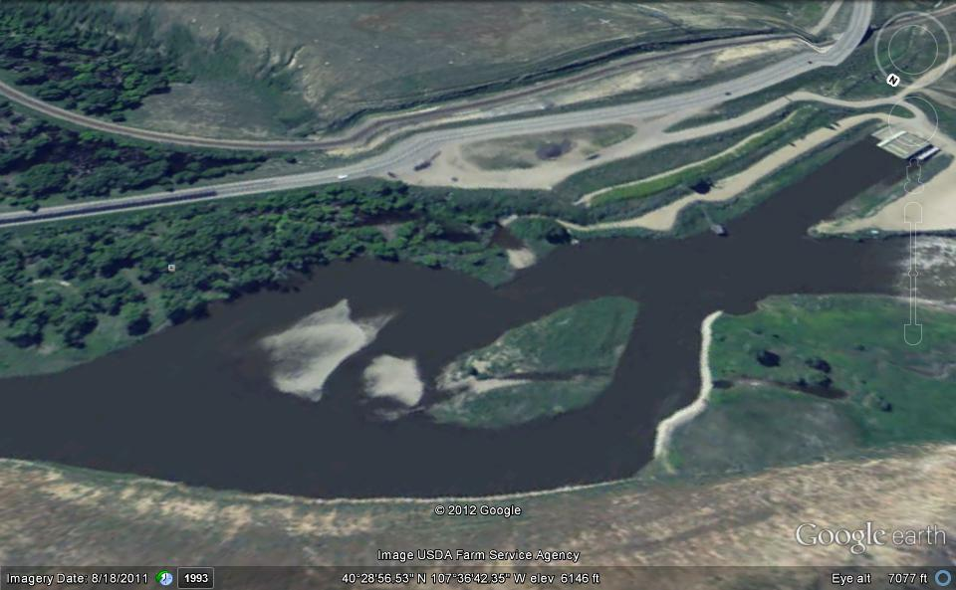

Bugs | Number | Tolerance | Index
Dobsonfly | 1 | S | 5
Caddisfly | 9 | S | 3
Mayfly Nymph | 40 | S | 3
Damselfly Nymph | 13 | F | 5
Stonefly Nymph | 87 | S | 3
Rat Tailed Maggot Larva | 41 | T | 3
Crane Fly Larva | 431 | F | 5
Midge Pupa | 38 | T | 3
Dragonfly Nymph | 76 | F | 5
Black Fly Larva | 24 | T | 3
Fingernail Clam | 11 | F | 5

Conclusion- Based on the data we collected, I assume the water quality in the Yampa River is proficient, because the river has insects that are water quality indicators that indicate the river is healthy. The tolerance score in the Yampa River is 22. The water quality is excellent.

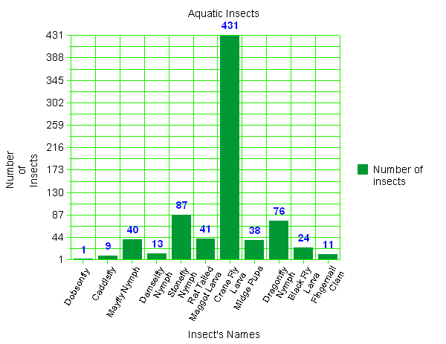

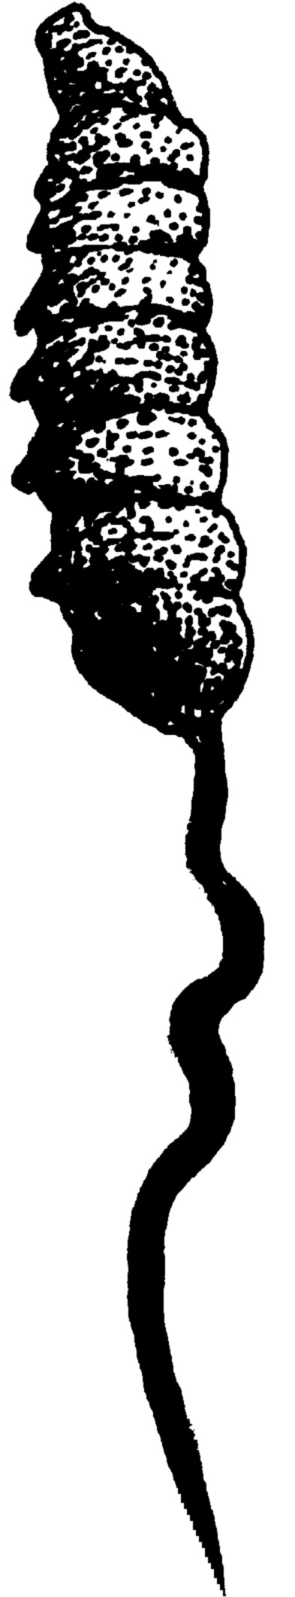

Rat tailed Maggot larva-
Larva of a Rat tailed Maggot gets to be 20mm long.

Damselfly larva-
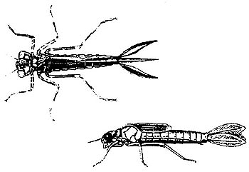
The Damselfly nymph can get to be 25mm long.

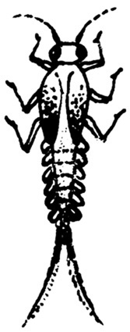

Mayfly nymph-
As an adult it will get up to 20mm.

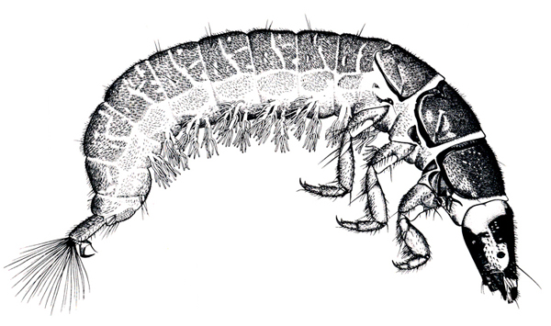
Caddisfly larva-
As an adult Caddisflies can get 30mm long.

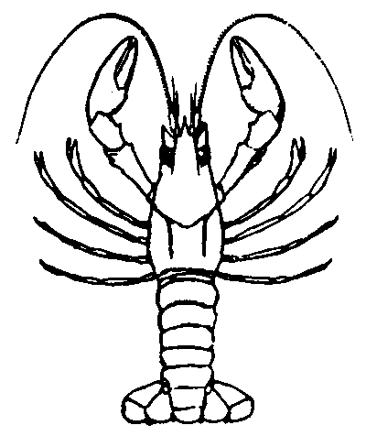

Crayfish-
A Crayfish will get at an average of 15cm long.
http://www.state.ky.us/nrepc/water/crayfish.htm

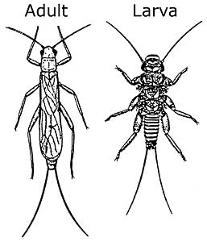
Stone Fly nymph-
Nymphs get to be 5-50mm in body length.
http://crawford.tardigrade.net/bugs/figures/pleco.jpg
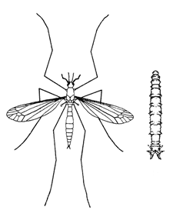

Crane fly larva-

These can get up to 3 inches long.

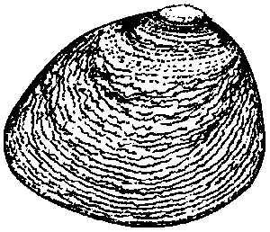

Fingernail clam-
Like their name the Fingernail clam, it is about the size of a fingernail.

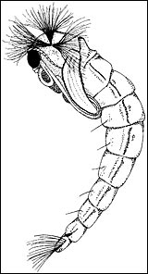

Midge Pupa- The smallest blood sucking insect known is the Midge. It is 1mm long.

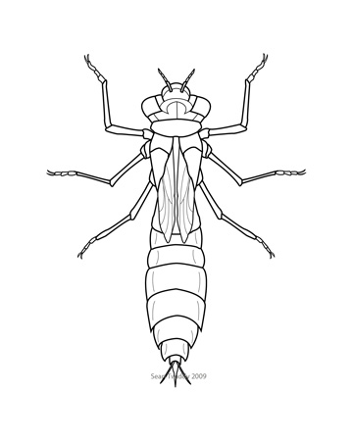

`

Dragonfly nymph- The Dragonfly nymph is about 25mm long.

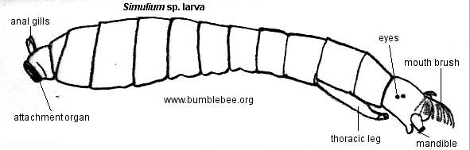
Blackfly larva- Adult Blackflies are 1-5mm long.
