Using Aquatic Macro-Invertebrates as Water Quality Indicators

By: Elizabeth Weis
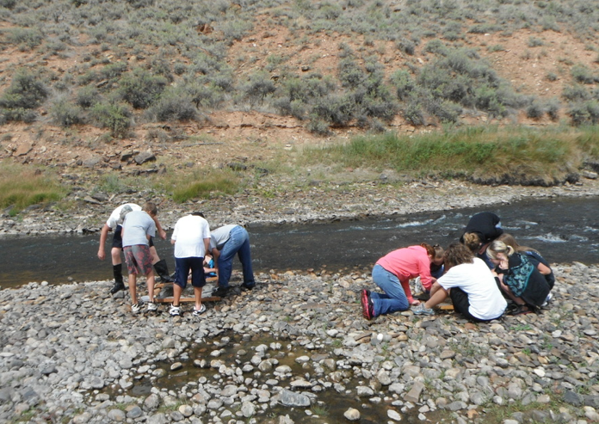

Date: 9/20/12

For: Riverwatch 2012

Purpose: To collect and count aquatic insects to determine water quality based on how many of certain bugs there are.

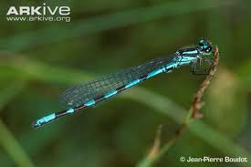

Materials: We used an insect collecting net, tweezers, rubbing alcohol, bowls, a jar, shoes, and insects.

Hypothesis: The river is very healthy because we found a lot of Stoneflies. Stoneflies indicate that the water is healthy because they are very low tolerance for pollution, and they need healthy water. We found a Dobson-fly, or a hellgrammite, which also needs clean water.

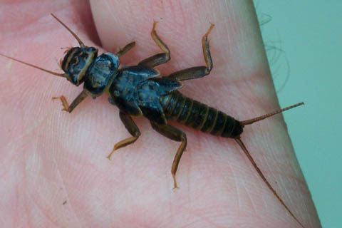

Procedure: We held the nets in the river while we had some people kicking up rocks. After about a minute of kicking we’d take the nets out of the river and pick out as many bugs as we could in around a minute. Then we’d put them in bowls with rubbing alcohol in them so they’d die. After 3 tests of that in 3 different areas, we put all the bugs in a jar.

Riparian Description: There were 3 pumps that were all taking water out of the river. One went to the power plant. Another one went to Trapper Mine. The last pump went to irrigation. There was a recreational area close by that had 6 campgrounds in it. Many people like to go down there to swim. The shore by the river was very rocky. Some of the rocks on the shore were rusting. This was a very great riparian area. There were many miscellaneous grasses, bushes, cottonwoods, some tamarisk trees, some willows, and more. There were some snakes, and I’m sure there are many foxes and deer down there too. It is in its channelized state. On a meander there was a wall of Gambian bags so that the side of the river wouldn’t erode away. The river was very low where we sampled, and the deepest it got was about 2 feet. The bottom of the river was also very rocky or pebbly. The pump for Trapper Mine vibrated the ground right by it a lot, and there was also a gigantic building for the pump that goes to the power plant.
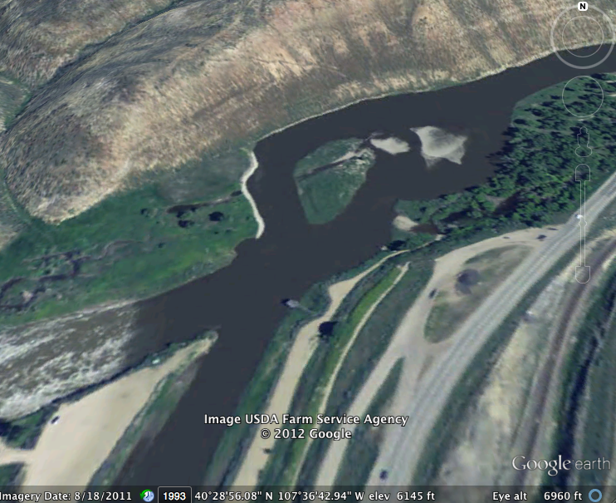
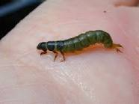

Data:
_{Bugs} | _{Number} | _{Tolerance} | _{Index}
_{Crayfish} | ₇ | _{Fair} | ₁₀
_{Caddis fly}  _{Larva} | ₉ | _{Sensitive} | ₁₂
_{Mayfly} | ₄₀ | _{Sensitive} | ₁₂
_{Damselfly} | ₁₃ | _{Fair} | ₁₀
_{Stonefly} | ₈₇ | _{Sensitive} | ₁₂
_{Rat Tailed}  _{Maggot Larva} | ₄₁ | _{Tolerant} | ₃
_{Crane-fly Larva} | ₄₃₁ | _{Fair} | ₁₀
_{Midge Pupa} | ₃₈ | _{Tolerant} | ₃
_{Dragonfly} | ₇₆ | _{Fair} | ₁₀
_{Blackfly Larva} | ₂₄ | _{Tolerant} | ₃
_{Fingernail Clam} | ₁₁ | _{Fair} | ₁₀
_{Dobson-fly} | ₁ | _{Sensitive} | ₁₂

Conclusion: The river is healthy. We found many macro-invertebrates. Most of them have sensitive tolerance to water pollution or anything else bad that might be in the water. All of the sensitive insects we found were in very high numbers. We only had 3 different types of bugs that were tolerant to anything. The rest were fair or sensitive. In the index, once you multiply and add it all it adds up to 25. Any number higher than 22 means the river has and excellent water quality rating. Even with the drought we’ve had, it is still in wonderful condition.

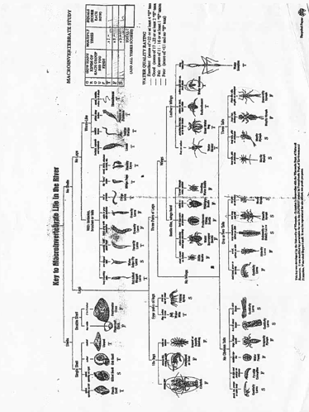
Google Images:
Crayfish
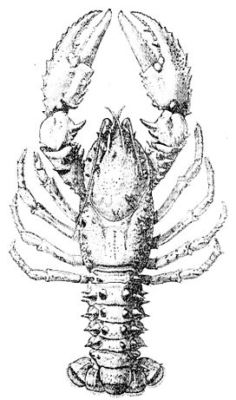
Caddis fly Larva
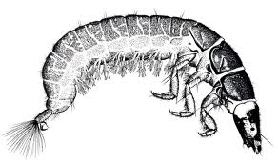
Mayfly Nymph
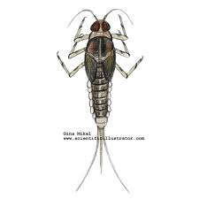
Damselfly Nymph

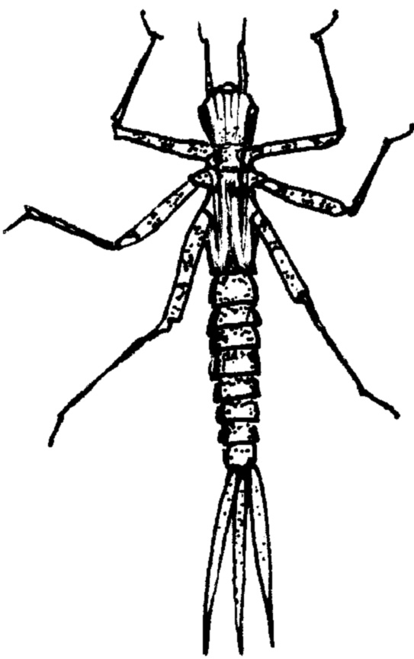
Stonefly Nymph
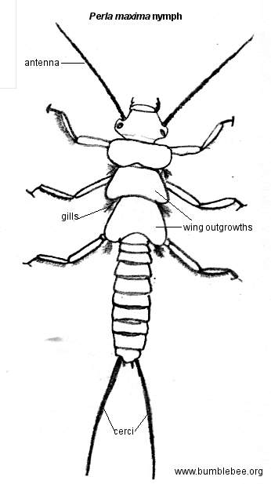

Rat Tailed Maggot Larva
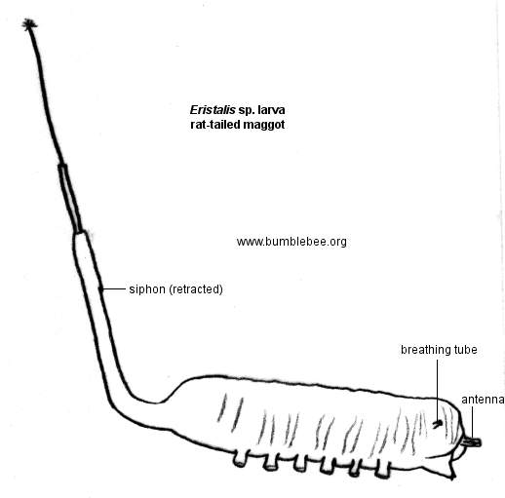
Crane-fly Larva
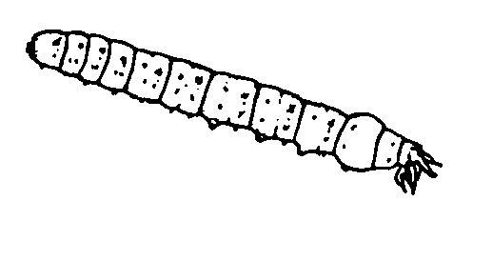
Midge Pupa
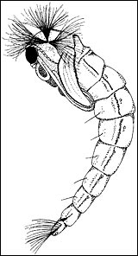
Dragonfly
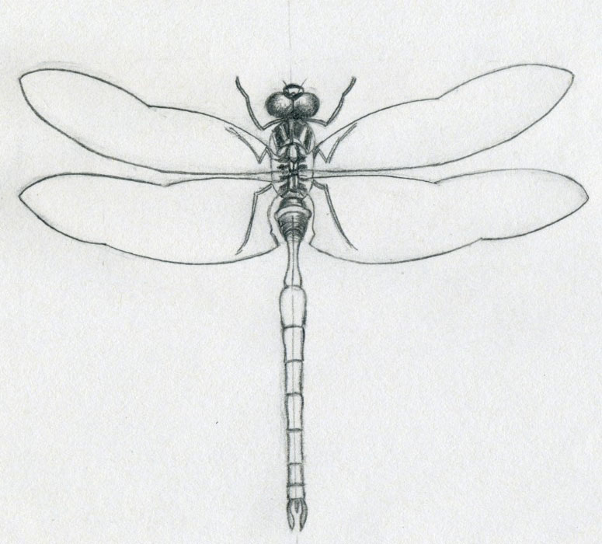

Blackfly Larva
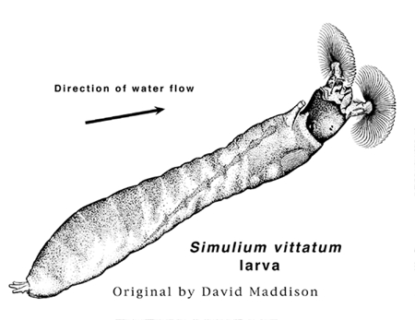
Fingernail Clam
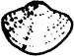
Dobson-fly
