Using Aquatic Macro-invertebrates as Water Quality Indicators

Kyann Kainz

Picture: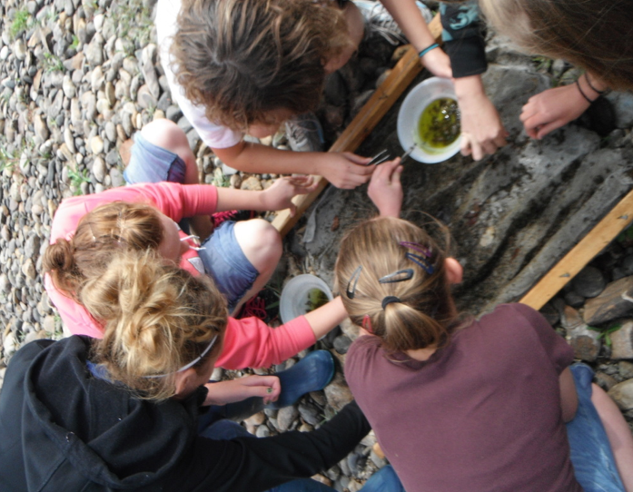
http://mryoast.weebly.com/river-watch.html

9-20-2012

River Watch 2012

Purpose:To collect aquatic insects to use as water quality indicators

Materials: Aquatic Insect collecting nets, shoes, tweezers, rubbing alcohol, bowls, a jar, insects

Hypothesis: The water would be very healthy, and we would find a lot of Aquatic Macro-invertebrates that were sensitive to polluted waters.

Procedure: We held Aquatic insect nets on the river bottom. We put rocks on bottom of net to secure so the insects could not escape the bottom. Then we kicked rocks up 10 steps away from the net after three minutes of kicking all the rocks in our area we took the nets up on shore, and pick all the insects we could off of our net. We would put the insects in a bowl that had rubbing alcohol in them, so they would die quickly. After repeating this two more times in different locations, and then put all insects collected in the jar.

Riparian Description:There were 3 pumps that were all taking water out of the river. The first pump we came to belonged to Trapper mine. The second water pump belonged to farmers and their irrigation. The third pump belonged to our power plant. There was also a large green building that was the pump house for the power plant.
The sides of the river were rocky and some of the rocks were rusting. The bottom of the river was rocky and moss was growing on the rocks. There were lots of Gambian bags on the side of the river to stop the river from meandering. There were cottonwoods, tamarisks, and willows. The ground was very dry, and there was not much grass. There were deer, magpies, and snakes.
The river was very shallow where we sampled. The deepest it got was probably around two feet. When Craig, Colorado is not in a drought the river is 4 to 5 feet in average.
.

Google Earth picture
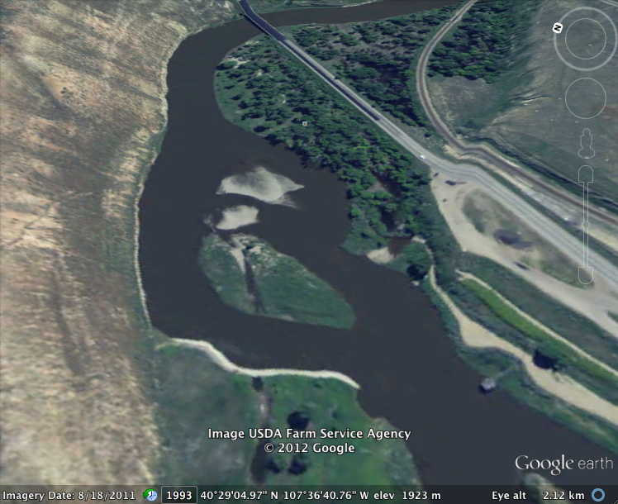

Data:
Insect | Number | Tolerance | Index
Rat tail Maggot Larvae | 41 | Tolerant | 3
Crane Fly Larva | 431 | Fair | 10
Midge popa | 38 | Tolerant | 3
Dragonfly Nymph | 76 | Fair | 5
Black Fly Larva | 24 | Tolerant | 3
Finger Nail Clam | 11 | Fair | 10
Dobson fly | 1 | sensitive | 12
Caddisfly Larva | 9 | Sensitive | 12
Mayfly Nymph | 40 | Sensitive | 12
Damesfly Nymph | 13 | Fair | 10
Stonefly Nymph | 87 | Sensitive | 12

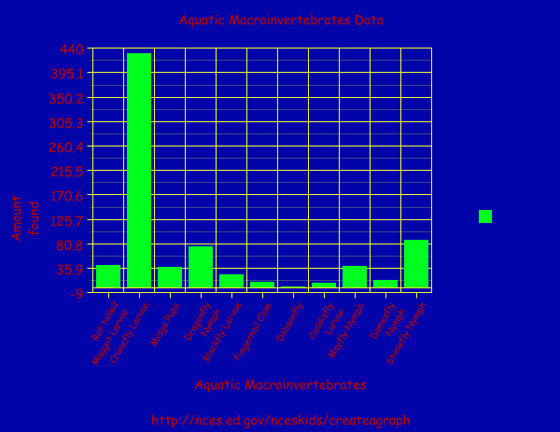

Conclusion on water quality based on data: The Yampa river, according to the Aquatic Macro-invertebrates that we collected, the river is healthy because we collected a lot of Aquatic Macroinvertebrates, and the majority of them are sensitive to polluted waters.

ID key used:

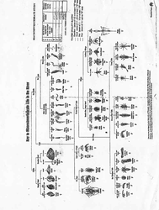
Appendix: Googleearth.com, mr.yoast.weebly.com,
www.ca.uky.edu/entomology/entfacts/ef500.asp,
http://www.west-fly-fishing.com/entomology/midges/midges_pupa_160.jpeg, http://www.state.ky.us/nrepc/water/dragfly.gif, http://www.riverwatch.ab.ca/how_to_monitor/images/inv-blackfly_larvae.gif,
http://seagrant.gso.uri.edu/factsheets/images/ss_fs.gif,
http://www.bio.umass.edu/biology/conn.river/insects-general.html, http://extension.entm.purdue.edu/pestcrop/2007/issue26/graphic26/CaddisflyLarva.jpg, http://whyevolutionistrue.files.wordpress.com/2011/05/paleozoic-mayfly-nymph.png, http://bcadventure.com/adventure/angling/bugs/damselfly/damsel-2.gif, http://bcadventure.com/adventure/angling/bugs/stonefly/sfnymph.gif

Aquatic Macro-invertebrates pictures

Rat tailed Maggot larvae
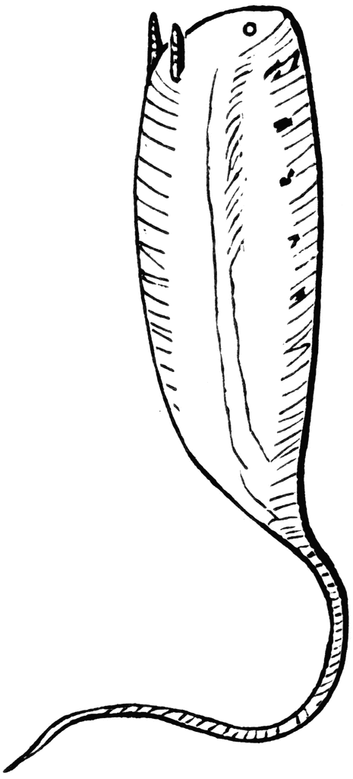

www.ca.uky.edu/entomology/entfacts/ef500.asp

Crane Fly larvae
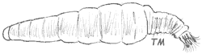
http://www.riverwatch.ab.ca/how_to_monitor/images/inv-cranefly_larvae.gif

Midge Pupa
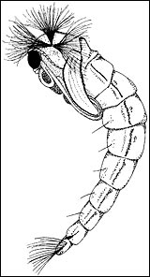

http://www.west-fly-fishing.com/entomology/midges/midges_pupa_160.jpeg

Dragonfly Nymph
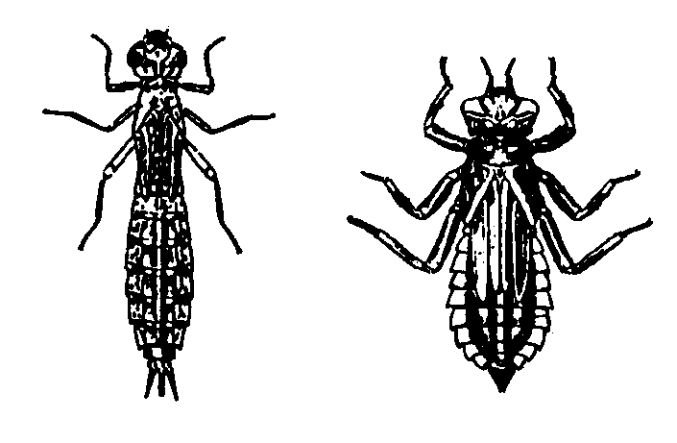

http://www.state.ky.us/nrepc/water/dragfly.gif

Black-fly Larvae
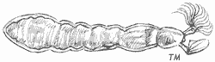

http://www.riverwatch.ab.ca/how_to_monitor/images/inv-blackfly_larvae.gif

Fingernail Clam
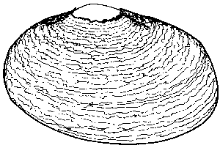

http://seagrant.gso.uri.edu/factsheets/images/ss_fs.gif

Dobsonfly
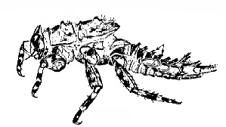

http://www.bio.umass.edu/biology/conn.river/insects-general.html

Caddisfly Larvae
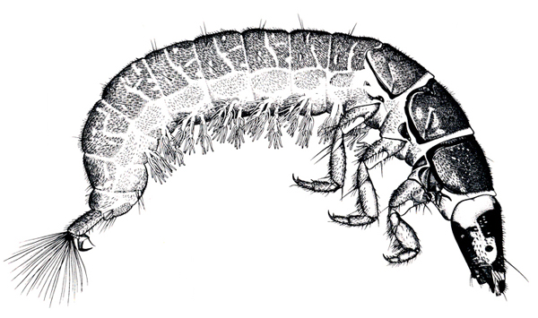
http://extension.entm.purdue.edu/pestcrop/2007/issue26/graphic26/CaddisflyLarva.jpg

Mayfly Nymph
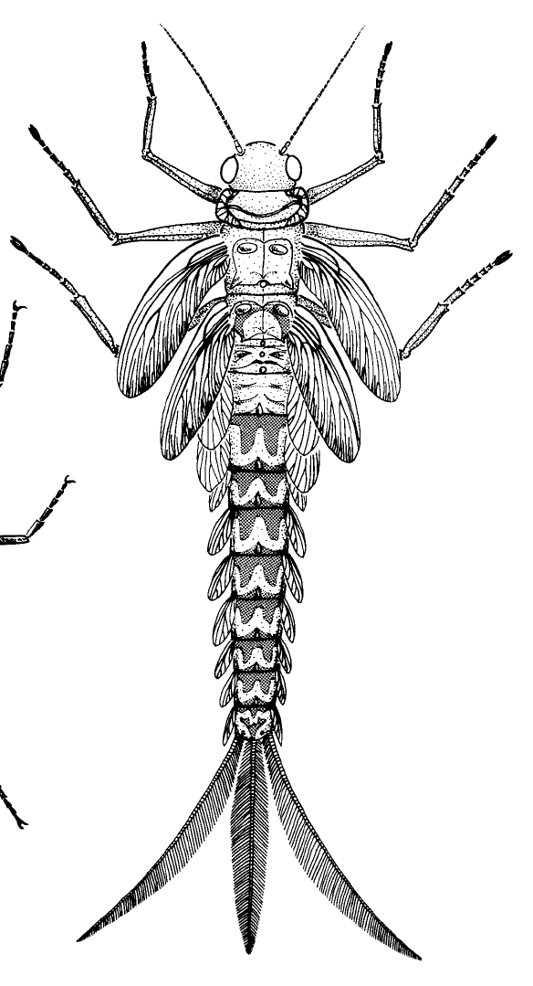

http://whyevolutionistrue.files.wordpress.com/2011/05/paleozoic-mayfly-nymph.png

Damselfly Nymph
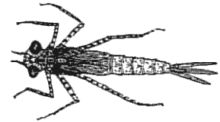

http://bcadventure.com/adventure/angling/bugs/damselfly/damsel-2.gif

Stonefly Nymph
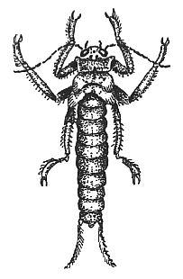

http://bcadventure.com/adventure/angling/bugs/stonefly/sfnymph.gif

