Aquatic Earthworms and other Worms 1/4” - 2”, can be very tiny; thin worm-like body. Tubifex worms shown. | 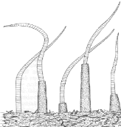

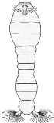 | Blackfly Larva Up to 1/4”, one end of body wider; black head, suction pad on end.

Midge Fly Larva Up to 1/4”, dark head, worm-like segmented body, 2 tiny legs on each side. Bright red or green body. Red ones also called bloodworms. | 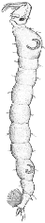
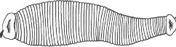 |  | Leech 1/4” - 2”, brown, slimy body, ends with suction pads.

Other Snails No operculum (hard end cover), breathe air; snail shell coils in one plane | 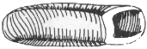
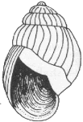 | Pouch Snail and Pond Snail No operculum (hard end cover). Breathe air; shell usually opens on left.

Rat-tailed Maggot 1/4” to 1”; the The body is covered with fine hairs and is wrinkled. The long tube is used to breathe.
Mosquito Larva and Pupa Fused segments makes the thorax thicker than the rest of body. They feed on algae and other bits of organic debris. Larva (top) pupa (bottom)

Two Point Critters Somewhat pollution tolerant organisms can be in good to fair quality water
Crayfish Up to 6”, 2 large claws, 8 legs, resembles small lobster | 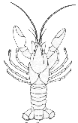
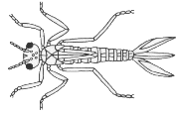 | Damselfly Larva 1/2” - 1”, large eyes, 6 thin hooked legs, 3 broad oar-shaped tails, positioned like a tripod. Smooth (no gills ) on sides of lower half of body.

Fingernail Clam Small | 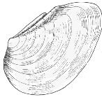
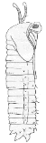 | Crane Fly Larva 1/3” -2”, milky green or light brown, plump caterpillar-like segmented body, 4 finger-like lobes at back end.

Scud 1/4”, white to gray, body higher than it is wide, swims sideways, more than 6 legs, resembles small shrimp. | 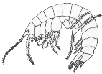
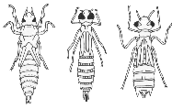 | Dragon Fly Larva 1/2” -2”, large eyes, 6 hooked legs; wide oval to round abdomen.

Alderfly larva 1” long; looks like small hellgrammite but has 1 long, thin, beached tail at back end (no hooks). No gill tufts underneath. | 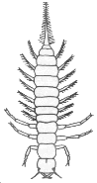
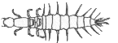 | Fishfly larva Up to 1 1/2” long; looks like small hellgrammite, but often a lighter reddish-tan color, or with yellowish streaks. No gill tufts underneath.

Sowbug 1/4”-3/4”, gray oblong body wider than it is high, more than 6 legs, long antennae. | 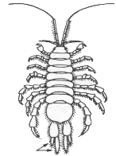 | 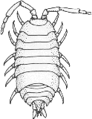

Three Point Critters Pollution sensitive organisms found in good quality water.
Stonefly Larva 1/2” - 1 1/2”, 6 legs with hooked tips, antennae, 2 hair-like tails. Smooth (no gills) on lower half of body. | 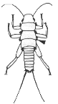
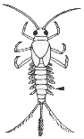 | Mayfly Larva 1/4” -1”, brown, moving, plate-like or feathery gills on sides of lower body, 6 large hooked legs, antennae, 2 or 3 long, hair-like tails. Tails may be webbed together.

Dobsonfly Larva (Hellgrammite) 3/4” - 4”, dark-colored, 6 legs, large pinching jaws, eight pairs feelers on lower half of body with paired cotton-like gill tufts along underside, short antennae, 2 tails and 2 pairs of hooks at back end. | 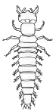
Caddisfly Larva Up to 1”; 6 hooked legs on upper third of body, 2 hooks at back end. May be in a stick, rock or leaf case with its head sticking out. May have fluffy gills tufts on lower half. | 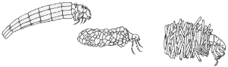

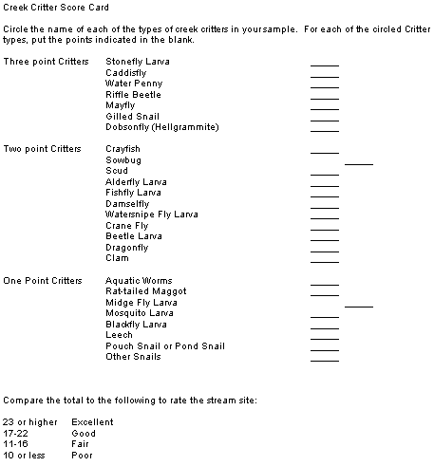
Water Penny 1/4” flat saucer-shaped body with a raised bump on one side and 6 tiny legs on the other side. Immature beetle. | 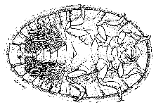
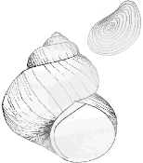 |  | Gilled Snail Shell opening covered by thin plate called operculum. Shell usually opens on right.

Riffle Beetle 1/4” oval body covered with tiny hairs, 6 legs, antennae. Walks slowly underwater, does not swim on surface. | 